LAB 2 Assignment: User Experience & Design Analysis — PharmEasy

1. Empathy Map — PharmEasy
User: Senior Citizen / Family Caregiver
Goal: Order essential prescription medications and book diagnostic lab tests at discounted prices with fast delivery.
Category | Details
SAYS | • "I want to upload my prescription and let them handle the order."  • "Which banner coupon actually gives the best discount?"  • "Why are there so many pop-ups while I try to find my cart?"  • "Are these lab packages genuinely comprehensive?"
THINKS | • "Will my required medicines be delivered on time before stock runs out?"  • "Is this pop-up trying to auto-add a paid membership plan to my bill?"  • "How do I find the plain generic salt name under all these brand badges?"  • "Did my uploaded prescription image go through properly?"
DOES | • Uploads prescription photos directly or searches using brand names.  • Clicks through discount banners looking for maximum savings.  • Attempts to dismiss intrusive promotional side-sheets and pop-ups.  • Reviews items in the cart drawer before entering payment details.
FEELS | • Confused: Overwhelmed by competing promotional ads and flashing banners.  • Anxious: Uncertain during prescription verification or delivery delays.  • Satisfied: Happy when securing good discounts or receiving door-step delivery.  • Annoyed: Frustrated by non-standard button styles and intrusive pop-ups.
Main Insight:
Users rely on PharmEasy primarily for budget-friendly medicine purchases and convenient lab test bookings, but struggle with heavy promotional clutter and non-standard interaction flows.
2. Pain Points — PharmEasy
Major Pain Points
- Aggressive Promotional Clutter: Flashing offer banners, cashback pop-ups, and membership upsells overwhelm the primary focal zone.
- Inconsistent Call-to-Action (CTA) Styles: Primary action buttons shift unpredictably between solid fills, stroke outlines, and text links across different screens.
- Ambiguous Prescription Flow: The visual distinction between searching directly and uploading a prescription is unclear for first-time users.
- Intrusive Upsells & Auto-Addons: Pre-checked healthcare plans or sample cart add-ons diminish user control during checkout.
- Accessibility Deficits: Low contrast text for secondary clinical details and missing screen-reader labels on promotional banners hinder low-vision users.
- Search & Zero-State Friction: Misspelled drug names or out-of-stock items often return empty screens without showing generic salt alternatives.
- Inconsistent Modal Components: Address entry and detail forms switch unpredictably between side-drawers and centered pop-up modals.
- Complex Navigation Menu: Overcrowded top menus blur the boundaries between pharmacy retail, diagnostic labs, and doctor consultations.
Key Pain Point:
"I want to order my daily medicines easily with good savings, but constant pop-ups, inconsistent buttons, and ad clutter make the process exhausting."
3. User Journey Map — PharmEasy
Persona: Ananya Roy (Caregiver for Aging Parents)
Goal: Order monthly prescription medicines and book a home lab test smoothly.
Stage | Action 1: Open App / Website | Action 2: Search Medicine / Upload | Action 3: Select Variant & Add to Cart | Action 4: Attach Prescription & Checkout | Action 5: Track Order & Receive
Task List | A. Open PharmEasy  B. Set delivery location pin  C. View home layout | A. Type medicine name  B. Or click Upload Prescription  C. Filter options | A. Pick tablet pack size  B. Select quantity  C. Add to cart drawer | A. Review cart items  B. Uncheck optional add-ons  C. Confirm payment | A. Monitor order status  B. Receive package  C. Verify items
Feeling | Curious, hopeful | Focused, attentive | Careful, checking details | Cautious, slightly annoyed | Relieved, satisfied
Adjective | Overwhelmed by banners | Confused by CTA styles | Reassured by discounts | Frustrated by upsell pop-ups | Satisfied by door-step service
Improvement Opportunities | De-clutter homepage and limit banner carousels. | Clarify "Search" vs "Upload" visual hierarchy. | Standardize button treatments across pages. | Remove pre-checked add-ons and modal interruptions. | Provide clear stage-by-stage verification updates.

4. Persona — PharmEasy
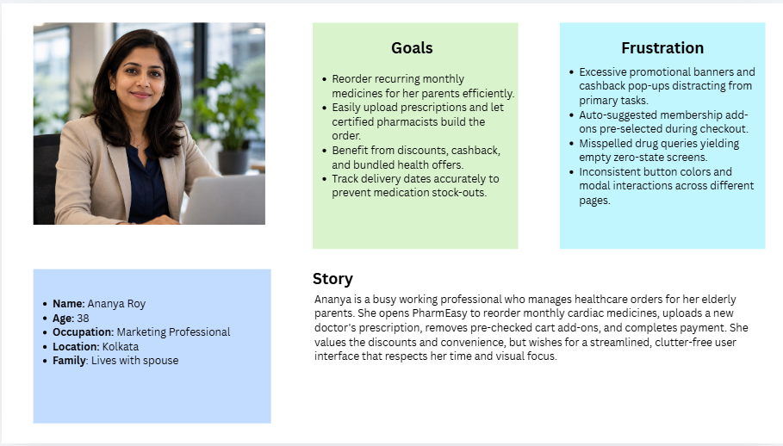
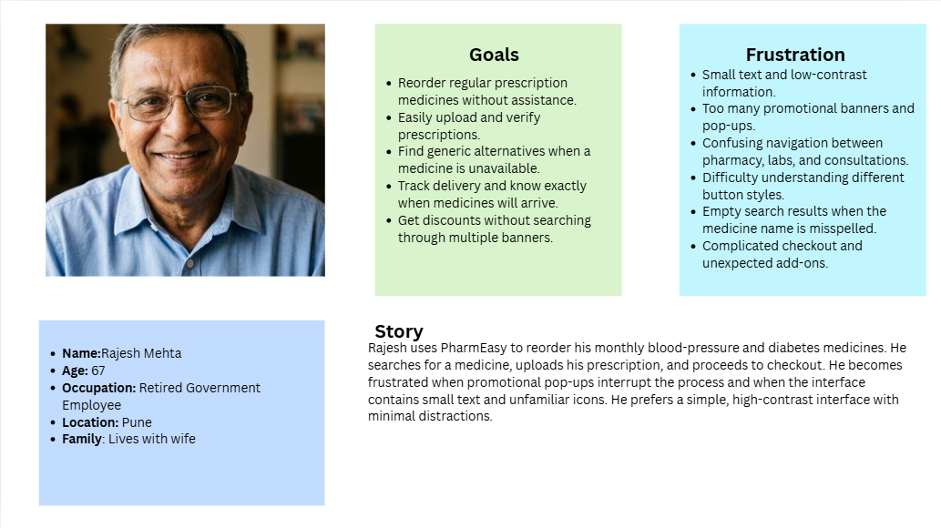
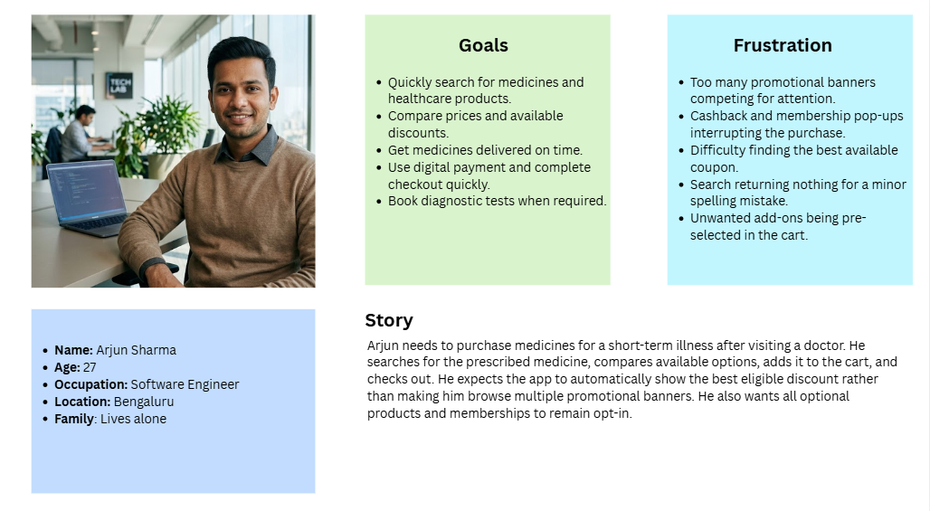
5. Gaps & Future Improvements
Current Gap | Future Improvement
Excessive Visual Clutter | De-clutter homepage, limiting banner carousels to maximum 3 primary slots.
Inconsistent CTAs | Implement a unified design system with standardized primary, secondary, and tertiary button styles.
Pre-Checked Cart Add-ons | Ensure all optional paid plans or sample items are opt-in rather than pre-selected.
Poor Search Zero-States | Implement smart auto-correct and generic salt recommendations for out-of-stock items.
Low Accessibility Contrast | Upgrade text contrast ratios and add mandatory screen-reader alt tags to all banners.
Modal Interaction Flaws | Standardize dialog behavior (e.g., consistent side-sheets for secondary tasks).
Future Features
- Express Refill Dashboard: A dedicated 1-click reorder widget on the main screen for saved chronic prescriptions.
- Unified Smart Search Engine: Multi-parameter search supporting brand names, active generic salts, health conditions, and symptom filters.
- Transparent Prescription Verification Tracker: A real-time visual progress widget showing Uploaded $→$ Pharmacist Reviewing $→$ Items Added to Cart.
- Elderly Assistance Mode: A simplified interface mode featuring larger font sizes, high-contrast buttons, and zero advertisement pop-ups.
- Automated Smart Coupon Finder: Automatically applies the maximum eligible discount code without forcing users to browse banner carousels.
- One-Tap Complaint & Refund Portal: Direct self-service resolution for missing, delayed, or damaged medicine packages.

